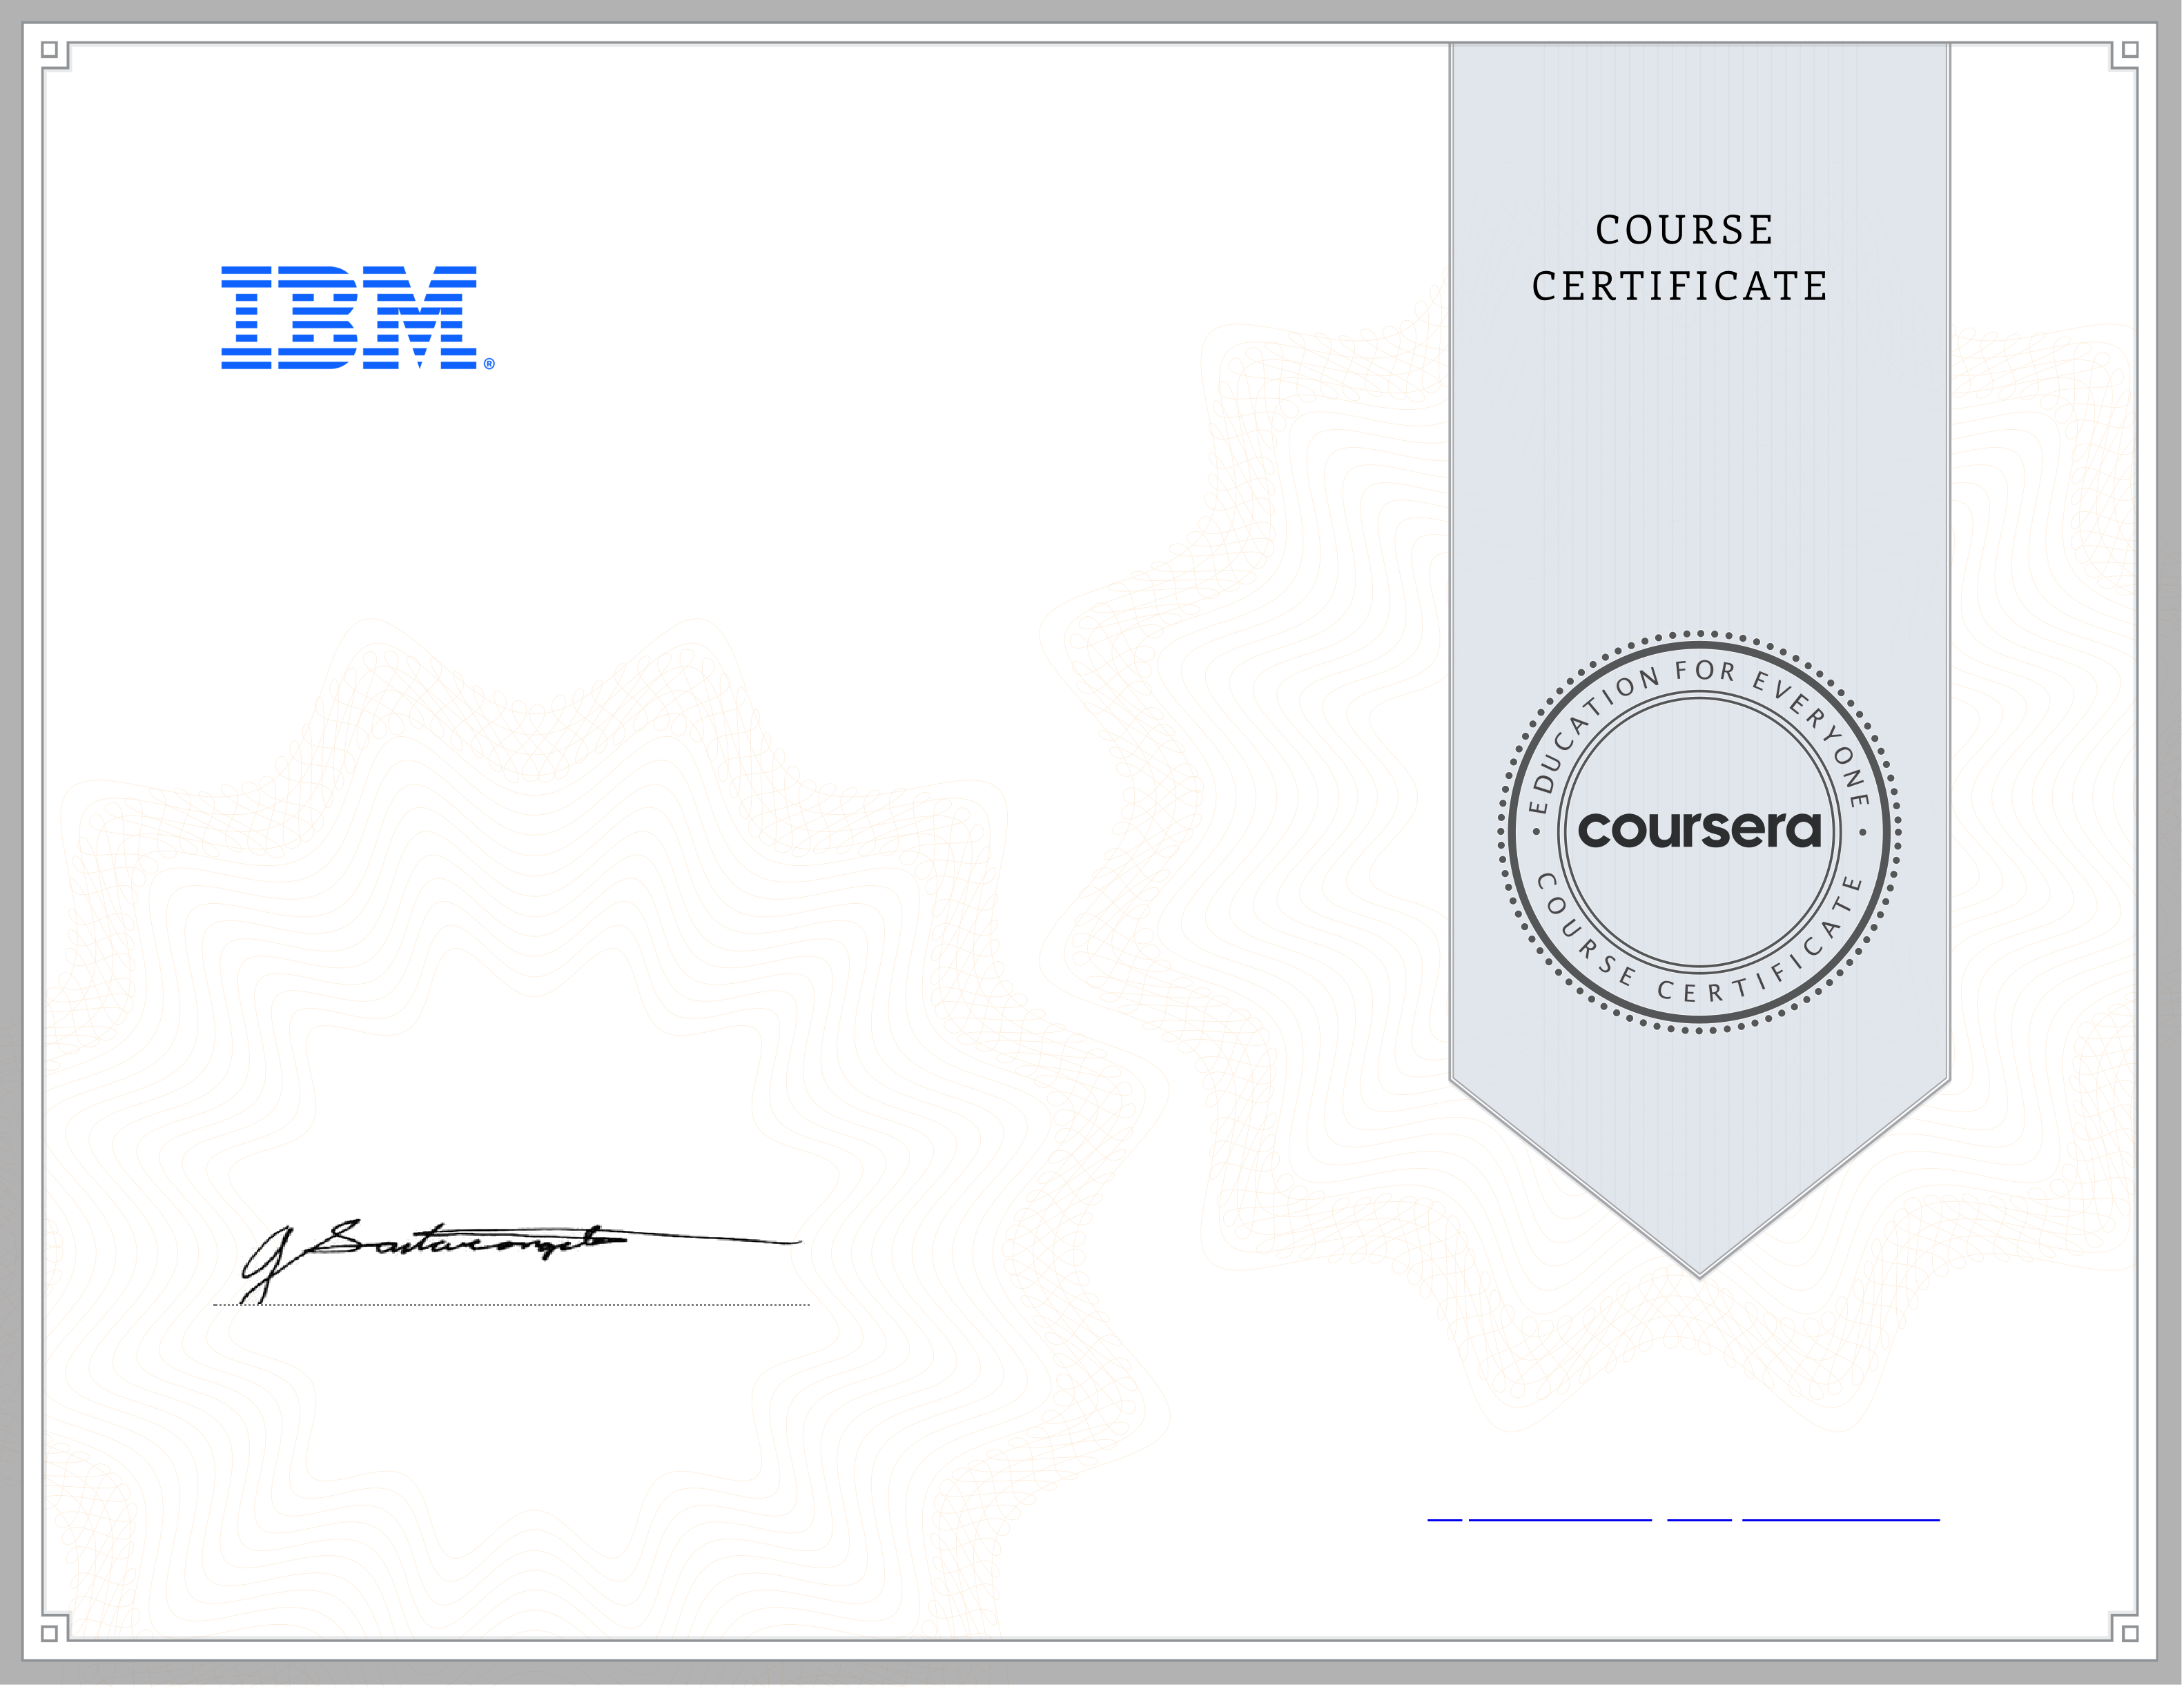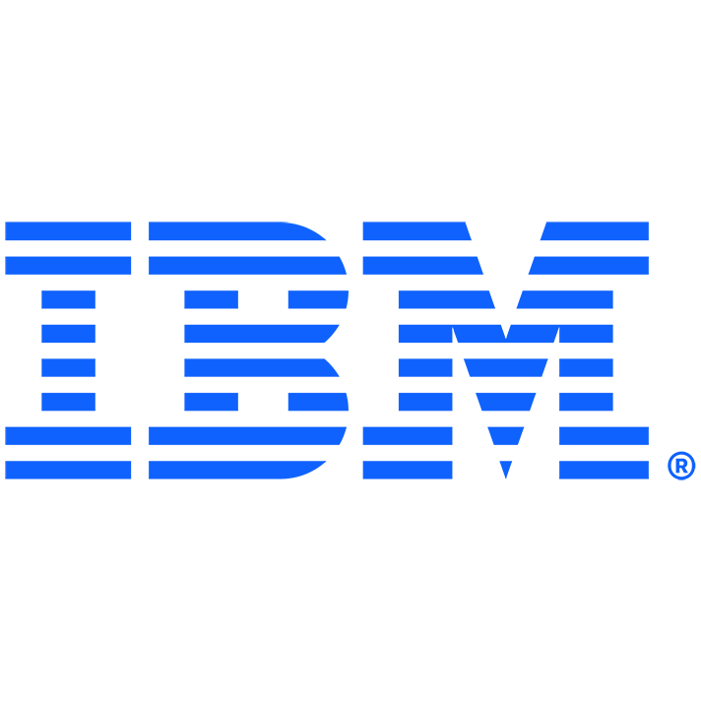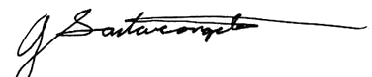

A ug 26, 2023   
Ahmed Taha   
has successfully completed   
Python for Data Science, AI & Development   
an online non-credit course authorized by IBM and offered through Coursera

Joseph Santarcangelo   
Senior Data Scientist   
IBM

[Verify at:](https://coursera.org/verify/LXVPKG86DYU5)   
 <https://coursera.org/verify/LXVPKG86DYU5>  
Cour ser a has confir med the identity of this individual and their

par ticipation in the cour se.